MyHealthRecord

UI Specification
version 1.7

14 September 2000

Introduction
This document outlines the design of the new User Interface for MyHealthRecord Web application. This document can be used as a UI guide for integrating healthcare application and content services into the MHR framework.

Background History
In May/June 2000, the Health Record strategy was released, proposing the MHR evolution from an “electronic shoe box” into a complete healthcare management center for the consumers.

Based on the strategy document, heuristic evaluations and several usability studies, the prototype of new design was created. This prototype was refined through further usability testing. The results of that testing were analyzed and incorporated into the final design presented in this document.

Goals of MHR UI Re-Design
- Make registration process easier
- Improve navigation
- Give users better sense of context within MHR site organization
- Better support users’ work flow
- Support new P2P functionality
- Define expandable architecture
- Enable easy integration of new applications
- Simplify visual presentation

Principles of MHR UI Re-Design
New MHR interface design is based on the user-centered design principles. MHR design empowers users to take more active role in managing their healthcare. Content and menu structure are organized for fast retrieval. Graphics are kept to minimum to speed download times. Meaningful and consistent button names are used to label sections and content areas. Constant visual and functional confirmation of the users’ whereabouts is provided via uniformly placed text and navigation cues. Maximum functionality and legibility of the interface is built on a consistent pattern of modular units, all sharing same basic layout, color themes, and hierarchies of organization. This consistency and predictability makes users feel comfortable exploring and using MHR.

General Design Characteristics

Technologies Used
MHR interface is presented through the web browser using HTML and ASP (active Server Pages). ASP templates are the backbone for organizing information and conserving space on MHR screens.

Template Structure
For maximum functionality and legibility, MHR interface is organized by defining clearly distinguishable areas. Information is chunked into four visual groups - components, based on functional similarity from the user's perspective.

The four components of MHR interface are the Header, the Navbar, the Workspace, and the Footer. Each of these components has its standard appearance and behavior.

The Navbar and the Workspace are located inside the horizontal space between the Header and the Footer, called the Body.

Header Area

Body Area

Navbar Workspace
Area Area

Footer Area

Use of Controls
Hyperlinks are used for navigating to locations and buttons for carrying out actions.

Form actions/buttons that continue or initiate the process must appear on the left, and buttons that cancel or reset the process must appear on the right:

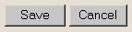

Some actions require user to first select one or more items in a list before clicking a button. If multiple selections are possible, then a check box is placed beside each item at the beginning of each row of data:

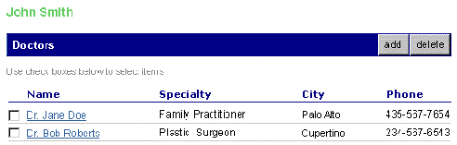

Check boxes and “Use check boxes below to select items” instructional notes appear only on the pages with records entered.

Font/Color Formatting
Single ASP style sheet file holds formatting data for UI elements, i.e., text, URLs, tables.

Template Components

The Header

Overview
The Header provides access to features that are of global use: Help, Feedback and Logout. Links to these features are positioned on the right side of the Header.
The Header also contains the WebMD and MHR logos, which are aligned to the left side of the Header.

Use of Controls
Control Name | Control Type | Interaction Style | Target Page | Target Area
Help | Textual link | Link color change on mouse-over | Help | Body
Feedback | Textual link | Link color change on mouse-over | Mail client | New window
Log out | Image Button |  | WebMD Consumer Portal | Whole window

Font/Link/Color Formatting
 | Hex Color Value | Font Face | Font Size | Font Weight | Text-decoration
Link | #FFFFFF | Arial | 9pt | Bold | None
Visited link | #FFFFFF | Arial | 9pt | Bold | None
Active(mouseover) link | #000080 | Arial | 9pt | Bold | Underlined
Background color | #9999CC
Body Text | #FFFFFF | Arial | 9pt | Normal | None

The Navbar
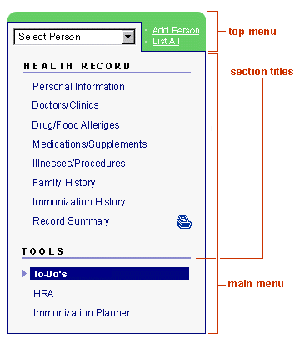
Overview
The Navbar is a primary mechanism for switching between MHR features.
The Navbar is easily distinguishable from content, and is placed in a consistent permanent location on the left side of the screen.

At the upper part of the Navbar is a drop-down list that provides access to the list of all people in the account. It allows users to select the person whose record they want to display. Beside the drop-down list there are links to Add Person and List All features. This top part is visually separated from the rest of the Navbar.
The lower part of the Navbar contains a text-based list of links to the Health Record and Tools features.

Use of Controls
Control Name | Control Type | Interaction Style | Target Page | Target Area
Select Person | Drop-down list | Select box  Default option: Person created a record | Record for selected person | Whole Page
Add Person | Textual link | Color change on mouse-over | Add Person | Workspace
List All | Textual link | Color change on mouse-over | List All People | Workspace
Personal Information | Textual link | Color change on mouse-over;  Cell background color change for (active) selected menu item ; arrow indicates selected item | Personal Information | Workspace
Doctors/Clinics | -- -- | -- -- | Doctors/Clinics | -- --
Drug/Food Allergies | -- -- | -- -- | Drug/Food Allergies | -- --
Illnesses/Conditions | -- -- | -- -- | Illnesses/Conditions | -- --
Medications/Supplements | -- -- | -- -- | Medications/Supplements | -- --
Family History | -- -- | -- -- | Family History | -- --
Immunization History | -- -- | -- -- | Immunization History | -- --
Record Summary | -- -- | -- -- | Record Summary | -- --
Print Icon | Image | -- -- | Record Summary | -- --

Font/Link/Color Formatting
 | Hex Color Value | Font Face/Style | Font Size | Font Weight | Text-decoration
Navbar background | #F6F6F6
Navbar outline | #000080
Main menu Link | #000080 | Arial | 10pt | Normal | None
Main menu Visited link | #000080 | Arial | 10pt | Normal | None
Main menu Active(mouseover) link | #FFFFFF | Arial | 10pt | Bold | None
Main menu Active (selected) cell background | #000080
Main menu Section title | #000000 | Arial/All Caps, double-spaced | 9pt | Bold | None
Main menu Section title underline | #8C8CCE
Top menu Link | #FFFFFF |  | 8pt | Normal | Underlined
Top menu Visited link | #FFFFFF |  | 8pt | Normal | Underlined
Top menu Active(mouseover) link | #000080 |  | 8pt | Normal | Underlined
Top menu background | #66CC66

The Workspace
The Workspace is where users do most of their work. Name of person whose record is currently displayed is left aligned at the top of the Workspace. Last Updated information is right aligned at the top. Highly visible page headers provide users with their location feedback. Page header text appears in the color tab and is left justified. On the right side of the tab there are buttons that allow user to add, delete and carry out other actions with records items:

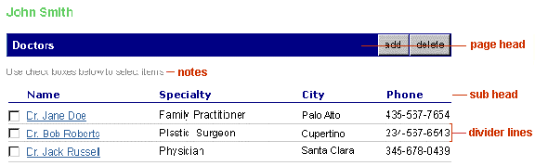

Record items are displayed in the table. Column headings for data are normally left aligned. Check boxes and “Use check boxes below to select items” instructional notes appear only on the pages with records entered.

Use of Controls
Some actions require user to first select one or more items in a list before clicking a button. If multiple selections are possible, then a check box is placed beside each record at the beginning of each row.

Use of Controls is page-specific for the Workspace. Please refer to section 7 Page Details and Workflow and mockups for more information.

Font/Link/Color Formatting
 | Hex Color Value | Font Face | Font Size | Font Weight | Text-decoration
Link | #006699 | Arial | 9pt | Normal | Underlined
Visited link | #660066 | Arial | 9pt | Normal | Underlined
Active(mouseover) link | #990066 | Arial | 9pt | Normal | Underlined
Person’s Name | #66CC66 | Verdana, Arial |  | Bold
Last Updated | #000000 | Arial | 8pt | Normal
Page Heading | #000000 | Verdana, Arial | 10pt | Normal
Page Heading Table Cell | #000080
Sub Heading | #FFFFFF | Verdana, Arial | 8pt | Bold
Sub Heading Underline | #000080 |  | Height=1px
Sub Heading Table Cell | #9999CC
Divider Lines | #DFDFDF |  | Height=1px
Support Notes | #8C8C8C | Arial | 8pt | Normal
Body Text | #000000 | Arial | 9pt | Normal

The Footer
The Footer at the bottom of each page contains standard copyright information on the left and log out button on the right.

Use of Controls
Control Name | Control Type | Target Page | Target Area
Log out | Image Button | WebMD Consumer Portal | Whole window

Font/Link/Color Formatting
 | Hex Color Value | Font Face | Font Size | Font Weight | Text-decoration
Body Text | #000000 | Arial | 8pt | Normal

Page Details and Workflow

Create Record (former Registration) Page

Data Fields
To create personal health record users have to provide the following information:

* indicates required field

- First name *
- Middle name
- Last name *
- Sex *
- Address
- City
- State
- Zip Code
- Country
- E-mail
- Phone (home)
- Date of birth

Emergency Contact
14. Last name
15. First name
16. Phone (home)

