Work Flow
The following diagram demonstrates the sequence of events that take place with respect to allocating trades:

Figure 1.

Screen Elements
All elements appear within an HTML table that defines the workspace area – a Workspace Table. The Workspace area appears as a white “page” on a dark blue browser background.

The FTT Logo is located at the very top-left of every screen.
A Company Name and User Name occupy two lines at the top-right corner of every screen.
A LOG OUT Button is located right under the Company and User Name information.

A Screen Title is located in a top-left area of each screen, right under the FTT logo.

A Trade Date and Settlement Date show a current date and a settlement date which is the third day following the trade date. Trade/Settlement date info occupies two lines in a top-left area of every screen right under the Screen Title.

Instructional Notes appear above the Data Table and under the Settlement Date (or, if applicable, under Action Buttons place above the Data Table):
- Note1 – Select multiple orders to create an Average Price Trade-- appears on every Trade Blotter screen that contains checkboxes for selecting individual orders
- Note2 -- To view or change allocation, click on blue symbol – appears on every Trade Blotter screen that contains allocated orders or AP trades

Footnotes are displayed under Action Buttons placed below Data Table:
- Footnote 1: * SEC fee is not included – appears on every screen that contains either Amount or Net Amount data.
- Footnote 2: * Commissions are not calculated until trade is allocated-- appears on every screen that contains Commission and Amount or Net Amount data.

Trade Details appear in a top-right area (above Data Table) of all screens except for the Trade Blotter, Create/Average Price Trade, and Today’s Allocations screens. On the Create Average Price Trade page Trade Details appear in a blue box in the middle of the screen. Trade Details are also repeated in an Account Allocation confirmation dialog.

Screen Element * | Font Face | Font Color | Font Size | Font Style | Margins | Background | Cell Padding
Body | N/A | link: #0066cc  vlink: #0066cc | N/A | N/A | 0,0 | #003366 | N/A
Workspace Table | N/A | N/A | N/A | N/A | - | #ffffff | 8
Company/User Name | Verdana, Arial | #000000 | 2 | Bold | N/A | N/A | N/A
Screen Title | Verdana, Arial | #000000 | 4 | Bold | N/A | N/A | N/A
Trade/Settlement Date | Verdana, Arial | #888888 | 2 | Bold | N/A | N/A | N/A
Instructional Notes | Verdana, Arial | #000000 | 1 | - | N/A | N/A | N/A
Footnotes | Verdana, Arial | #000000 | 1 | - | N/A | N/A | N/A
Trade Details | Verdana, Arial | B: #007733  S: #dd0033  O: #000000 | 2 | Bold | N/A | N/A | N/A

Trade Blotter/Average Price Trade table formatting
Table Row/Columns | Font |  |  |  | Cell
Table Row/Columns | Face | Color | Size | Style | Background | Alignment | Padding | Border
Header | Arial | #000000 | 2 | - | #cccccc | H: center  V: center | L, R: 2px  T, B: 1px | L, T: 1px solid #dddddd;  R, B: 1px solid #666666;
“AP Trade” Row:  Select  Avg.  Symbol  Side  Quantity  Price  Commission  Amount  Venue  Tracking #  Allocated | - | - | 2 | - | #d0e0f0 | V: center | L, R: 2px  T, B: 0px | -
 | N/A | N/A | -//- | - | -//- | H: center | -//- | -
 | N/A | N/A | -//- | - | -//- | H: center | -//- | -
 | Verdana, Arial | #000000 | -//- | Bold | -//- | H: left | -//- | -
 | Verdana, Arial | B: #007733  S: #dd0033 | -//- | Bold | -//- | H: left | -//- | -
 | Verdana, Arial | #000000 | -//- | Bold | -//- | H: center | -//- | -
 | Verdana, Arial | #000000 | -//- | - | -//- | H: right | -//- | -
 | Verdana, Arial | #000000 | -//- | - | -//- | H: center | -//- | -
 | Verdana, Arial | #000000 | -//- | - | -//- | H: right | -//- | -
 | Verdana, Arial | #000000 | -//- | - | -//- | H: center | -//- | -
 | Verdana, Arial | #000000 | -//- | - | -//- | H: center | -//- | -
 | Verdana, Arial | #000000 | -//- | - | -//- | H: center | -//- | -
“Order” Row:  Select  Avg.  Symbol  Side  Quantity  Price  Commission  Amount  Venue  Tracking #  Allocated | - | - | 2 | - | #e0e0e9 | V: center | L, R: 2px  T, B: 0px | -
 | N/A | N/A | -//- | - | -//- | H: center | -//- | -
 | N/A | N/A | -//- | - | -//- | H: center | -//- | -
 | Verdana, Arial | #000000 | -//- | - | -//- | H: left | -//- | -
 | Verdana, Arial | B: #007733  S: #dd0033 | -//- | - | -//- | H: left | -//- | -
 | Verdana, Arial | #000000 | -//- | - | -//- | H: center | -//- | -
 | Verdana, Arial | #000000 | -//- | - | -//- | H: right | -//- | -
 | Verdana, Arial | #000000 | -//- | - | -//- | H: center | -//- | -
 | Verdana, Arial | #000000 | -//- | - | -//- | H: right | -//- | -
 | Verdana, Arial | #000000 | -//- | - | -//- | H: center | -//- | -
 | Verdana, Arial | #000000 | -//- | - | -//- | H: center | -//- | -
 | Verdana, Arial | #000000 | -//- | - | -//- | H: center | -//- | -
Footer | N/A | N/A | N/A | N/A | #999999 | N/A | N/A | N/A

Table Notes:
- All colors are referred to as HEX values
- When describing font colors for Trade Details, B stands for Bought, S stands for Short/Sell, O stands for Other
- When describing font colors for Side, B stands for Bought, S stands for Short/Sell;
- When describing cell formatting, V stands for Vertical, H for Horizontal alignment;
- When describing cell formatting, T stands for Top, B for Bottom, L for Left, and R stands for Right border

Account Allocation/Summary table formatting
Table Row/Columns | Font |  |  |  | Cell
Table Row/Columns | Face | Color | Size | Style | Background | Alignment | Padding | Border
Header | Arial | #000000 | 2 | - | #cccccc | H: center  V: center | L,R:40px  T, B: 1px | L, T: 1px solid #dddddd;  R, B: 1px solid #666666;
Allocation Accounts  Account Number  Account Name  Quantity | - | - | - | - | - | V: center | L, R: 2px  T, B: 0px | -
Allocation Accounts  Account Number  Account Name  Quantity | Verdana, Arial | #000000 | 2 | - | - | H: center | -//- | -
Allocation Accounts  Account Number  Account Name  Quantity | Verdana, Arial | #000000 | 2 | - | - | H: right | -//- | -
Allocation Accounts  Account Number  Account Name  Quantity | Verdana, Arial | #000000 | 2 | Bold | - | H: right | -//- | -
Unallocated  Account Number  Account Name  Quantity | - | - | - | - | #cccccc | V: center | L, R: 2px  T, B: 0px | -
Unallocated  Account Number  Account Name  Quantity | N/A | N/A | N/A | N/A | #cccccc | N/A | -//- | -
Unallocated  Account Number  Account Name  Quantity | Verdana, Arial | #000000 | 2 | Bold | #cccccc | H: right | -//- | -
Unallocated  Account Number  Account Name  Quantity | Verdana, Arial | #000000 | 2 | Bold | #cccccc | H: right | -//- | -
Footer | N/A | N/A | N/A | N/A | #999999 | N/A | N/A | N/A

Today’s Allocations table formatting
Table Row/Columns | Font |  |  |  | Cell
Table Row/Columns | Face | Color | Size | Style | Background | Alignment | Padding | Border
Header | Arial | #000000 | 2 | - | #cccccc | H: center  V: center | L, R: 5px  T, B: 1px | L, T: 1px solid #dddddd;  R, B: 1px solid #666666;
Today’s Allocations:  Account Number  Account Name  Symbol  Side  Quantity  Price  Commission  Net Amount | - | - | - | - | - | V: center | L, R: 2px  T, B: 0px | -
 | Verdana, Arial | #000000 | 2 | - | - | H: center | -//- | -
 | -//- | #000000 | -//- | - | - | H: right | -//- | -
 | -//- | #000000 | -//- | - | - | H: left | -//- | -
 | -//- | B:#007733  #dd0033 | -//- | - | - | H: left | -//- | -
 | -//- | #000000 | -//- | - | - | H: center | -//- | -
 | -//- | #000000 | -//- | - | - | H: right | -//- | -
 | -//- | #000000 | -//- | - | - | H: center | -//- | -
 | -//- | #000000 | -//- | - | #f0f1ee | H: right | -//- | -
Dividers | N/A | N/A | N/A | N/A | #999999 | N/A | N/A | N/A
Footer | N/A | N/A | N/A | N/A | #999999 | N/A | N/A | N/A

Create Average Price Trade screen
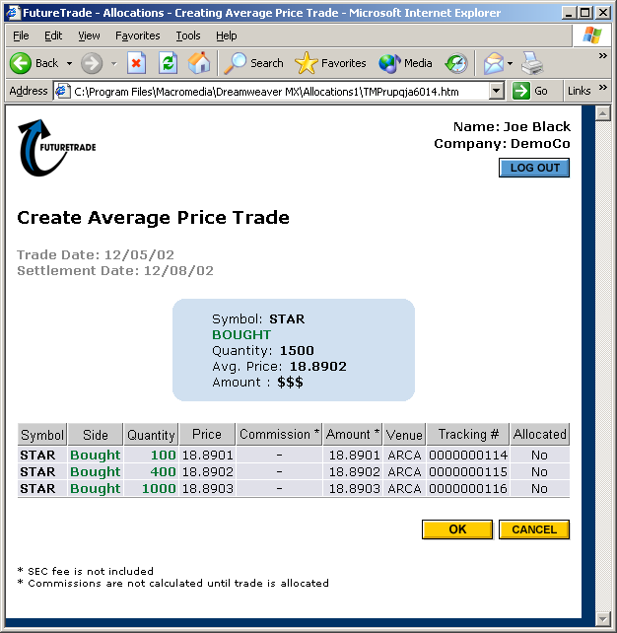

Account Allocation screen
